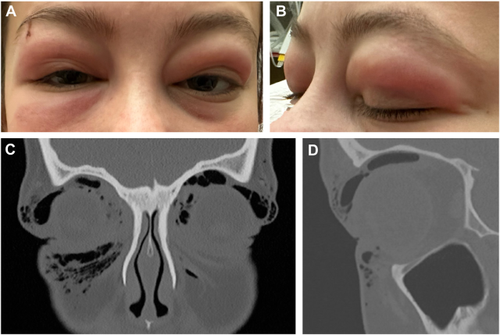

A 21-year-old woman presented to the emergency department with 3 days of worsening periorbital swelling (A, B). She had recentlycompleted a Tik-Tok challenge in which she induced air reflux through the nasolacrimal system by forcefully blowing against a pluggednose. Computed tomography scans (C, coronal; D, sagittal) demonstrated bilateral subcutaneous and orbital emphysema with no orbitalfractures. Based on the provided images and clinical description please make an ophthalmic diagnosis for this patient. And output the diagnostic conclusions only.

**Orbital Emphysema**